1. Antognazza, Maria Rosa, 2009, Leibniz: An Intellectual Biography, Cambridge.
2. Deleuze, Gilles, 1988/1993 (Trans. Tom Conley), The Fold: Leibniz and the Baroque, University of Minnesota Press.
3. Descartes, Spinoza, Leibniz (“Monadology”); The Rationalists 1974, Anchor Books.
4. Halpern, Paul, 2020, Synchronicity: The Epic Quest to Understand the Quantum nature of Cause and Effect, Basic Books.
5. Girardot, Norman, 1983, Myth and Meaning in Early Taoism: Theme of Chaos (hun-tun), University of California Press.
6. Mungello, D. E., 1999, The Great Encounter of China and the West, 1500 – 1800, Rowman & Littlefield publishers, Inc.
7. Rovelli, Carlo, 2020/2021, (Trans. Erica Segre), Helgoland: Making Sense of the Quantum Revolution
8. Swetz, Frank J., Leibniz, the *Yijing*, and the Religious Conversion of the Chinese, Mathematics Magazine, Vol. 76, 2003, Issue 4
9. Smolin, Lee, Einstein’s Unfinished Revolution: The Search for What Lies Beyond the Quantum, Penguin Press.
10. Strickland, Lloyd, 2014, Leibniz’s Monadology, A New Translation and Guide, Edinburgh Press.
11. Strogatz, Steven, 2019, Infinite Powers: How Calculus Reveals the Secrets of the Universe, Harcourt.

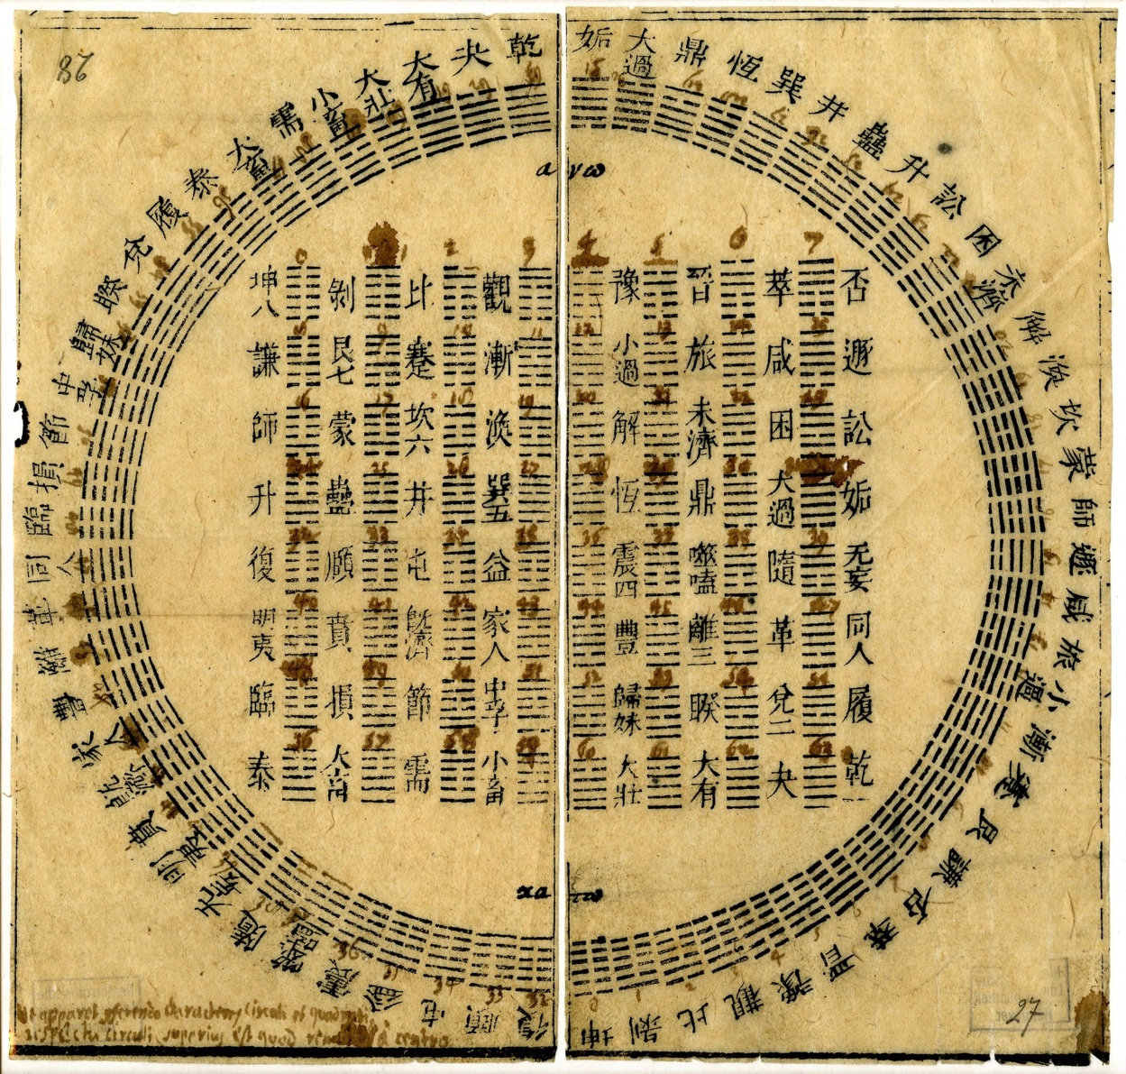

*The sixty-four hexagrams of the I Ching (Yijing) was a re-drawn version that was first published by Gorai Kinzō (in a study of Leibniz's interpretation) sent by the Jesuit Priest, Joachim Bouvet to Leibniz in 170,. The numerical equivalents (from 0 to 63) are inscribed by Leibniz’s own hand at the top of each hexagram. (Leibniz Archive, Hannover, Germany).*